NUAC FAB – a joined Danish and Swedish “Functional Airspace Block”
In 2009, the Danish and Swedish Air Navigation Service Providers realised the plans for expansion of cooperation and formed a joint subsidiary “NUAC”. Within the next few years NUAC will be responsible for providing Air Navigation Service in both Danish and Swedish airspace as a Functional Airspace Block (FAB). It will ultimately be beneficial for airlines, travellers and the environment through a more efficient Air Traffic Control. The two Nordic countries have thereby proven to be in front when it comes to realise EU's ambition to harmonize and streamline the Air Traffic Management in Europe.

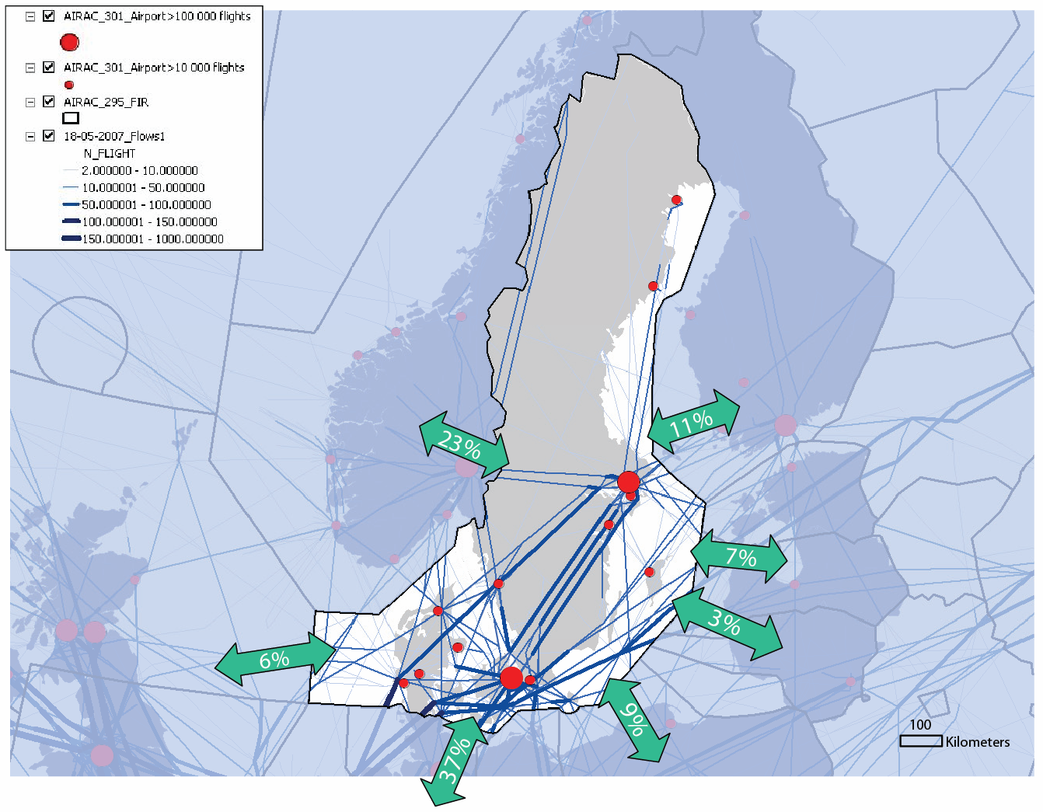
NUAC FAB - distribution of flights in perspective of the European ATM Network

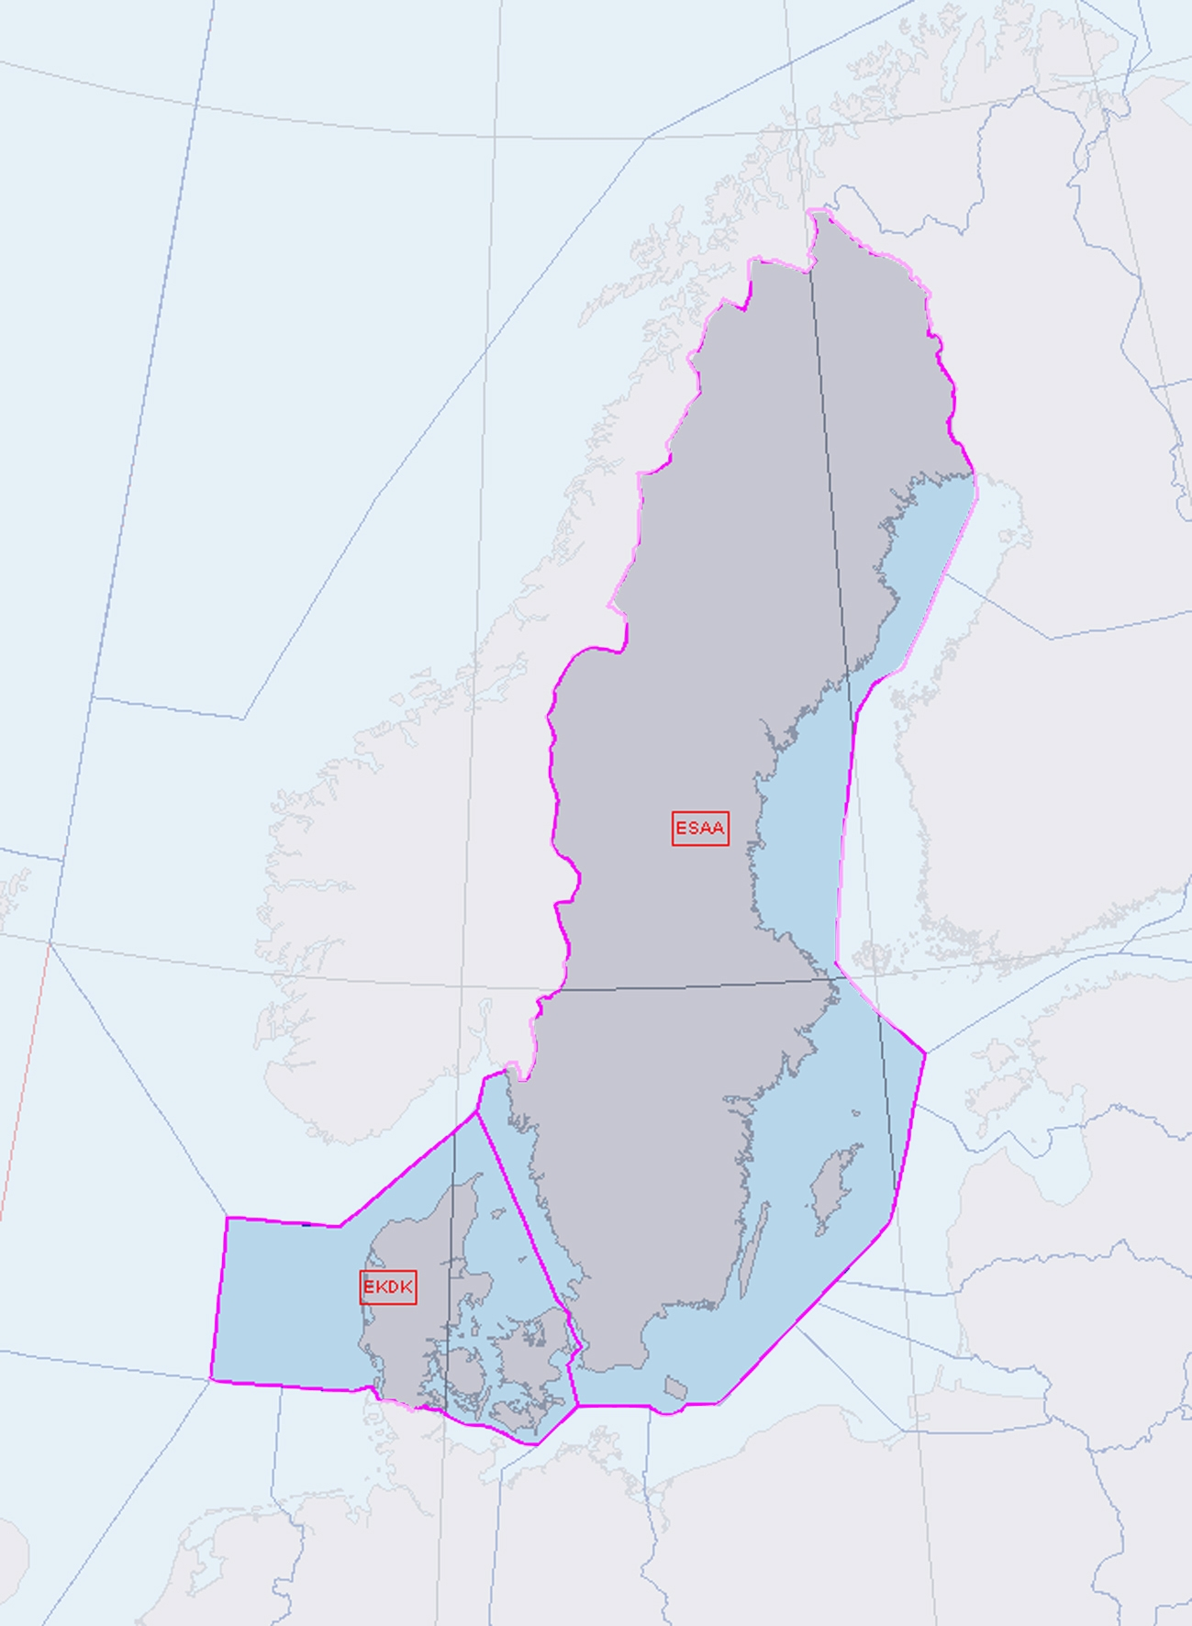

Danish and Swedish Airspace

