Bilag 1 til pressemeddelelse fra Flyvesikringstjenesten/NAVIAIR d. 18.1.2002

RVSM Facts

The Reduced Vertical Separation Minimum (RVSM) Programme will increase airspace capacity in the European airspace by providing six additional flight levels between 29,000 feet (FL290) and 41,000 feet (FL410) inclusive. This will be achieved by reducing the separation minima between aircraft from 2000ft to 1000ft. The RVSM programme will go live on 24 January 2002 in the airspace of 41 European and North African countries. This period coincides with the weakest demand for air travel in the year and is thus the best time for controllers, pilots and flight planners to get used to the new system.

The European airspace is the first continental airspace to introduce RVSM between FL290 and FL410. It is the biggest change in Europe’s airspace in the past fifty years. The RVSM Programme was developed and managed by EUROCONTROL, the European Organisation for the Safety of Air Navigation, at the behest of the air travel industry, following studies showing that reducing vertical separation minima would be the best way to deal with increasing airspace congestion.

RVSM will have a number of positive effects on the air traffic flow in Europe’s airspace:

- capacity in Europe’s airspace will increase by an estimated 20%
- its total cost-benefit ratio is 1:14¹
- the yearly cost benefit for operators is estimated at 3.9 billion €1, mostly from delay reductions and fuel savings
- RVSM will contribute significantly to passenger satisfaction by reducing delays.

As 2001 draws to a close, it is clear that RVSM is ready to be launched on schedule. All necessary air traffic control (ATC) procedures, phraseology and manuals have been developed and distributed in due time; ATS systems have been modified to comply with RVSM requirements; almost all airframes operating between FL290 and FL410 have been certified; the ATCs of 41 countries have been trained and are on schedule for implementation. Moreover, the pilots and flight planners of 2,300 operators have been properly trained and prepared.

To ensure ATCs get used to managing aircraft in an RVSM environment, capacity will only be raised gradually after the introduction of RVSM, and is expected to reach its estimated target of 120% in September 2002.

The safety of RVSM is guaranteed by ensuring full aircraft certification processes for 104 aircraft types, and individual certification for 9,300 airframes operating in RVSM airspace. This certification is backed up by an ongoing programme of monitoring the height-keeping accuracy of aircraft using European airspace.
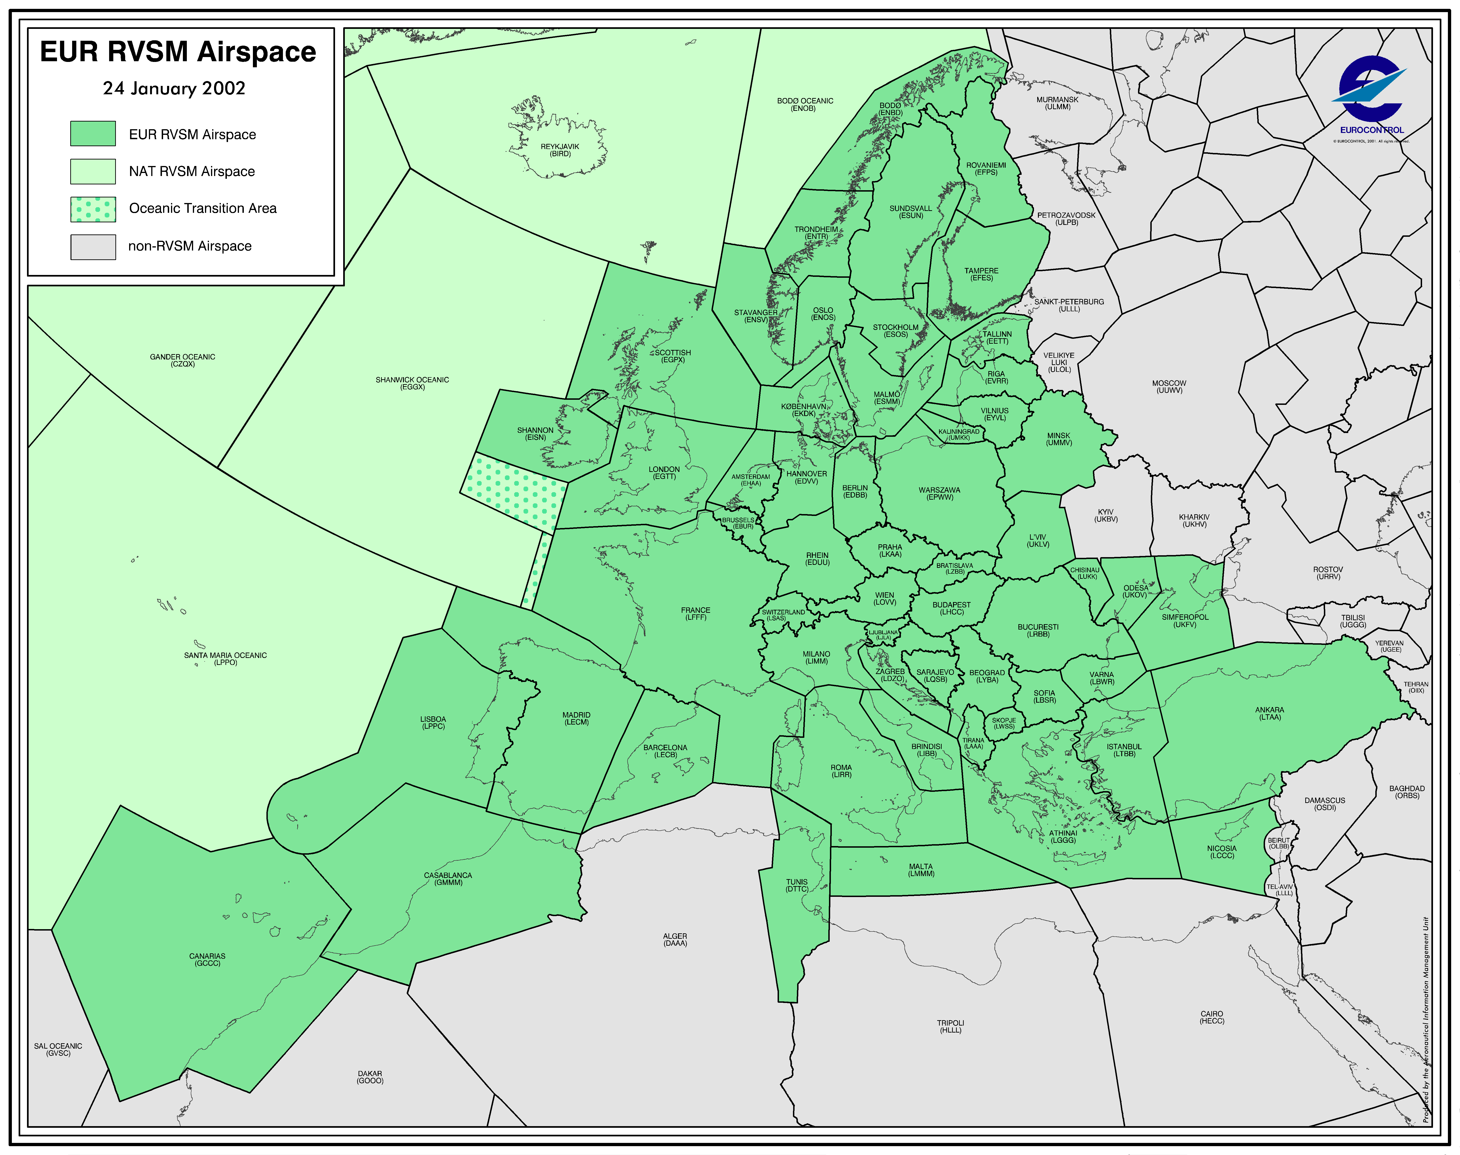
RVSM has involved training for all controllers in the implementing States and pilots of 2,300 aircraft operators. RVSM briefings have also been given to flight planners.

This map shows the area in which RVSM will be implemented on 24 January 2002.

Information taken from PA Consulting study, January 1999

